**Comparing The Social economic Factors of GDP, Molarity, Immunization On Life expectancy Basing on correlations Against The social-Economic factors Of total expenditure ,alcohol On life expectancy basing on Correlations**

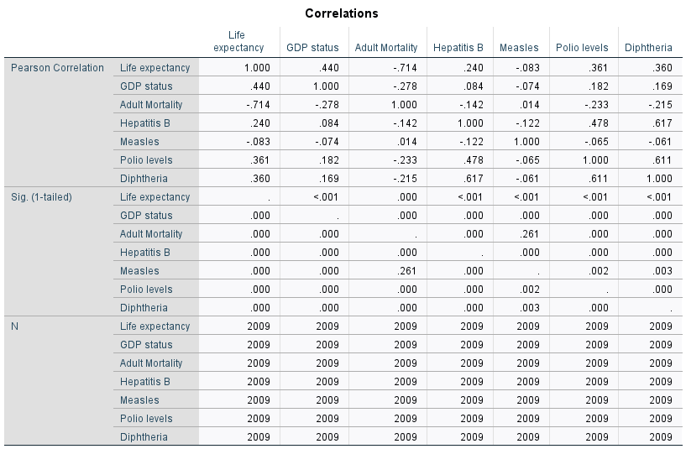

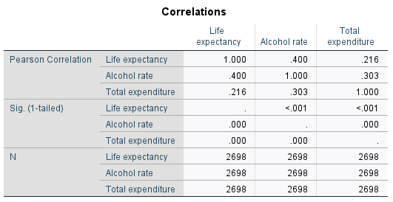

**Summary on validation**

Basing on the first model, the significant predictors affecting the life expectancy where GDP, Hepatitis B, Measles and Polio and the least significant was Adult molarity While as Basing on the second model, all predictors(Alcohol, Total expenditure) were affecting life expectancy